Communciation System Lab’s Report  
Kotlin Homework2



Name: 雷智豪

Class: 電子三甲

Student ID: 111360155

Group : 雷智豪 111360155

鄭光佑 109360105

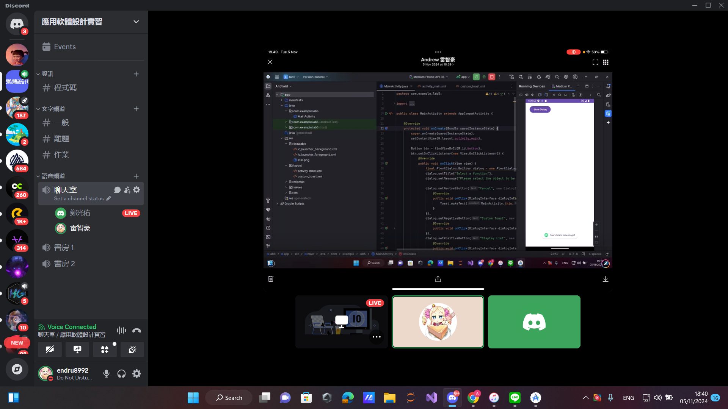

LAB 4 – Activity:

Java :

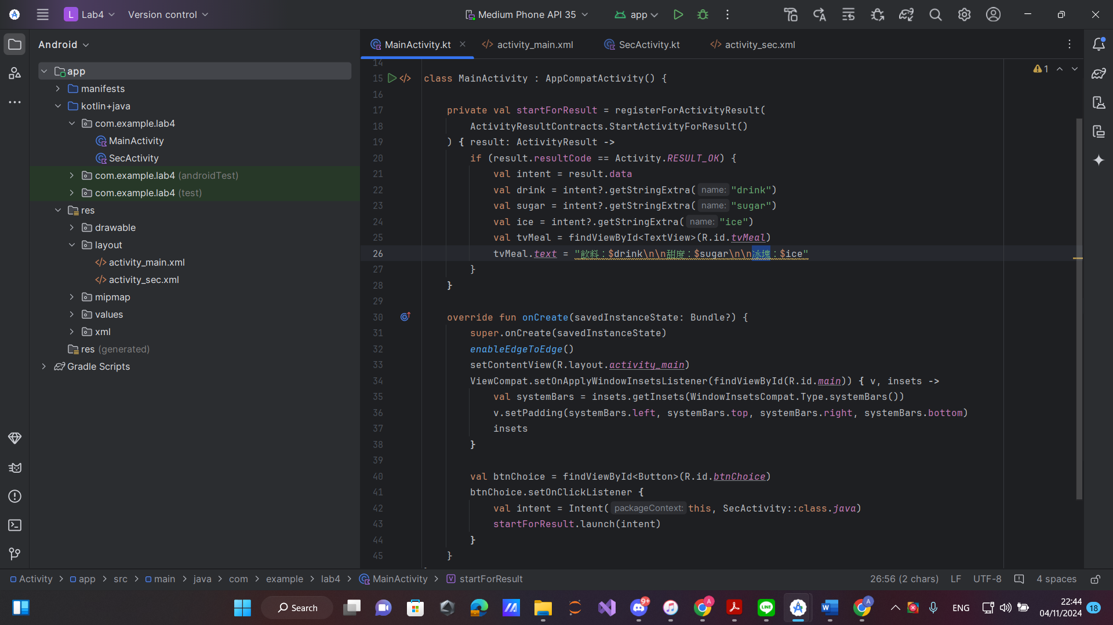

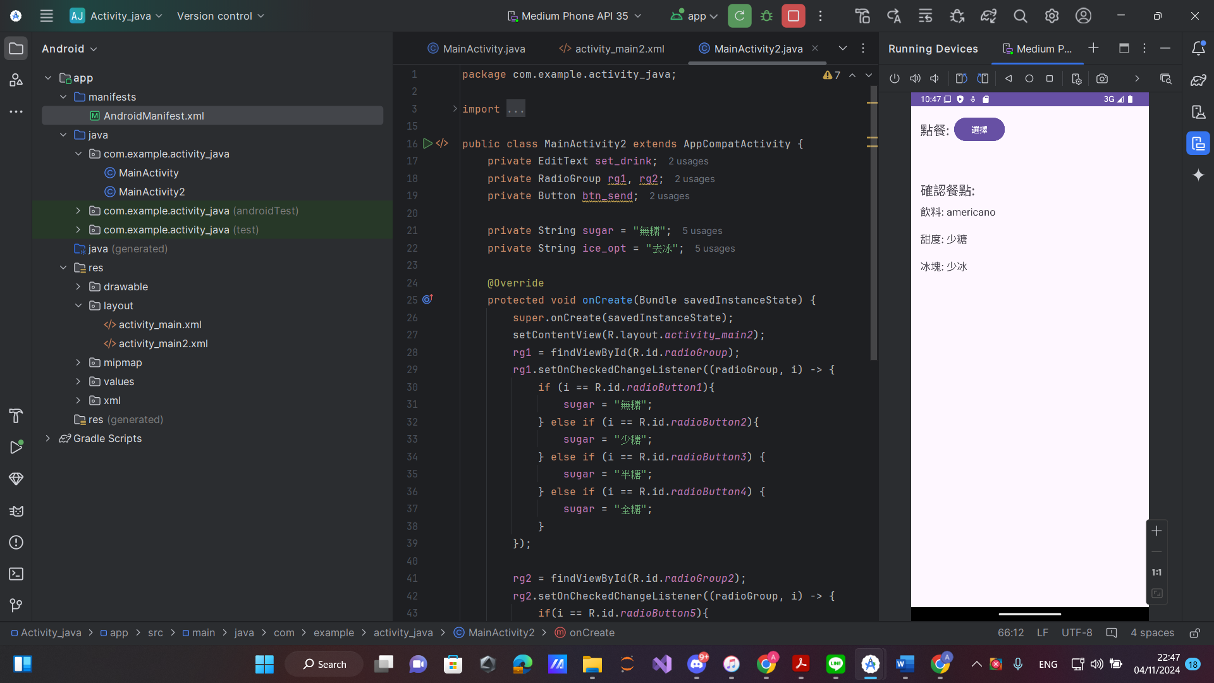

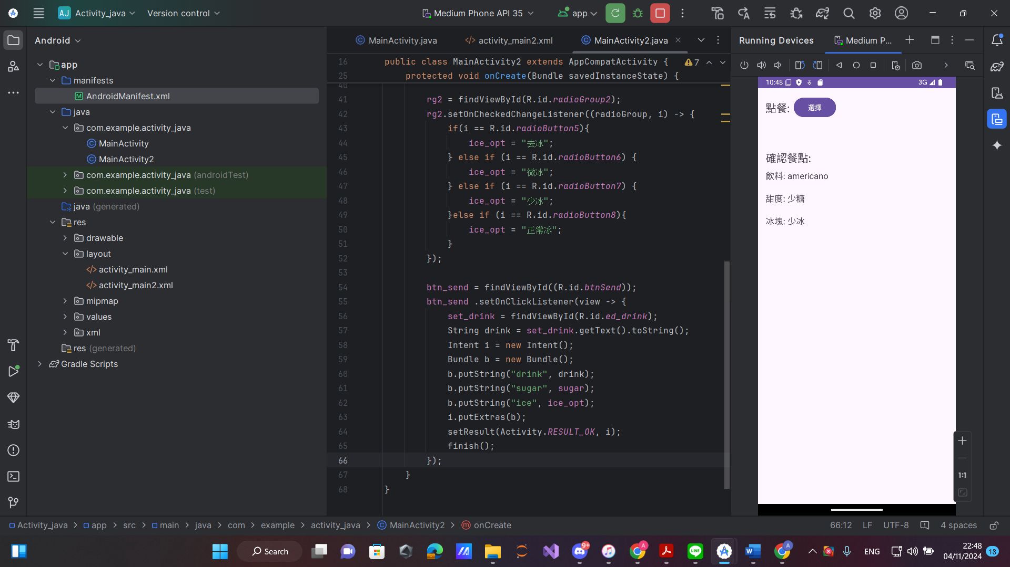

Kotlin:

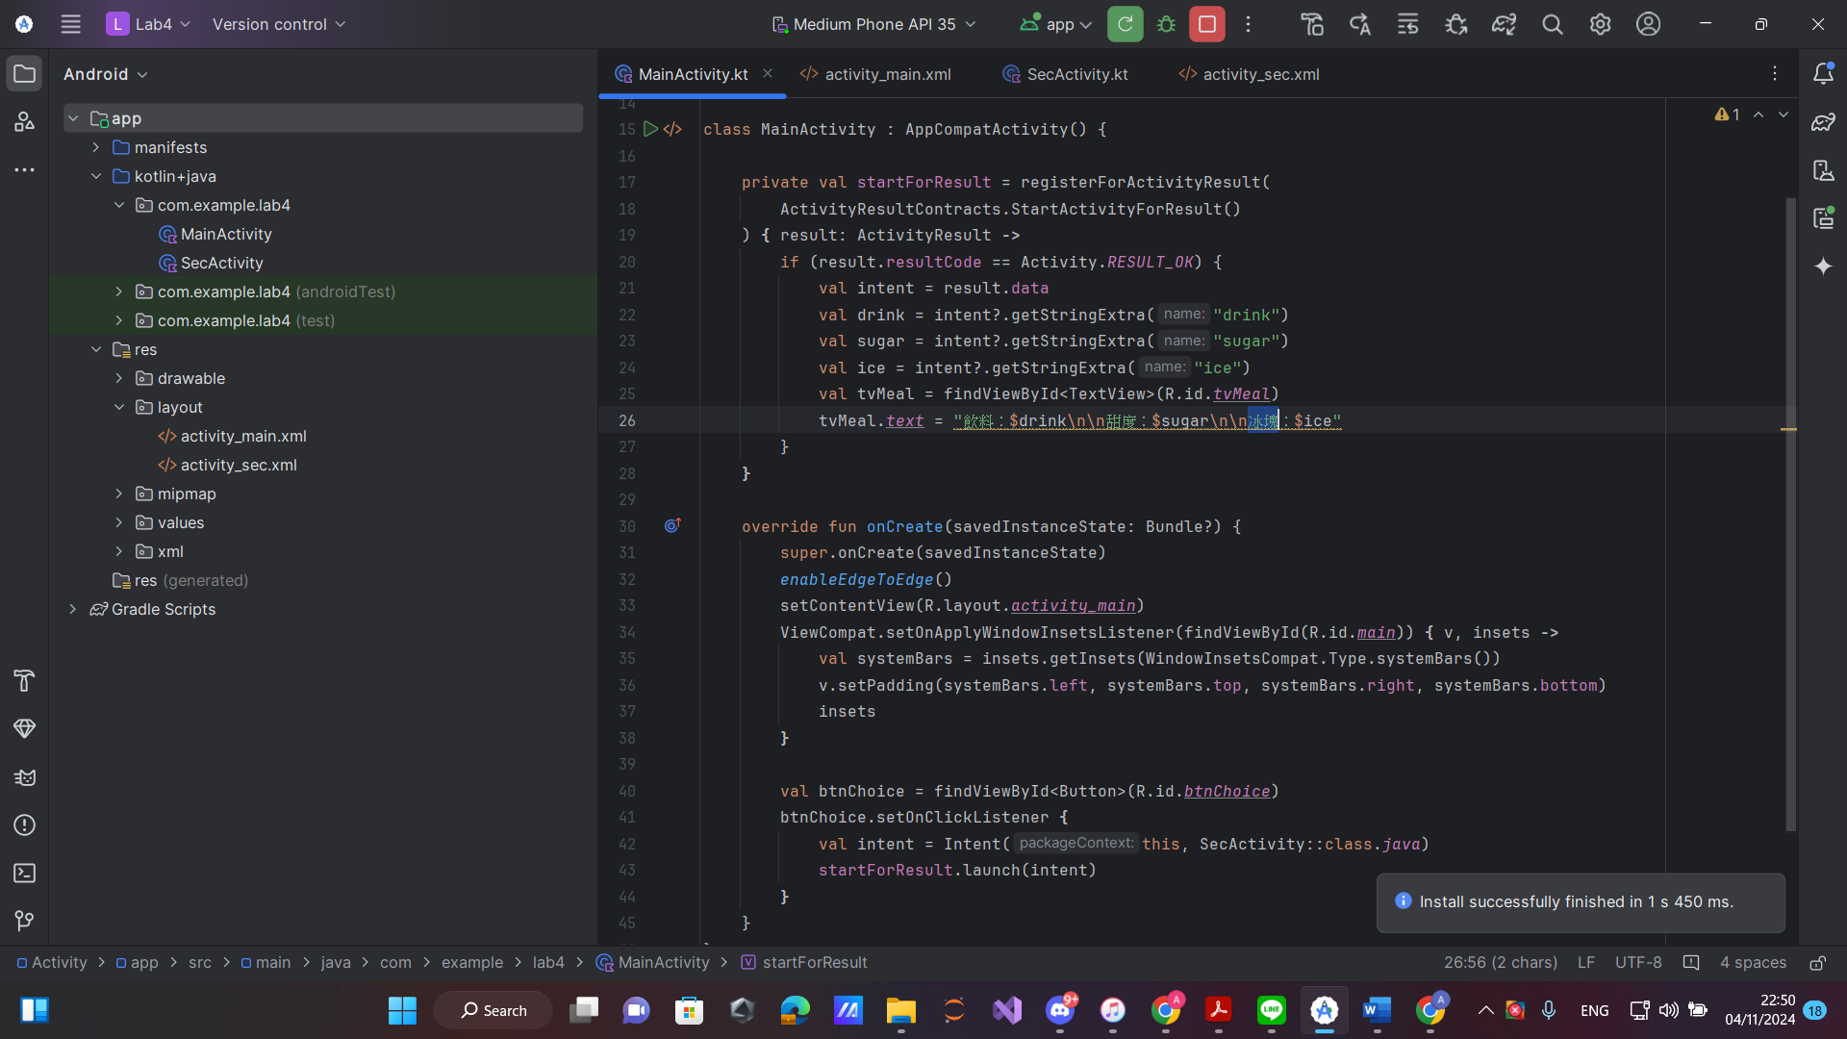

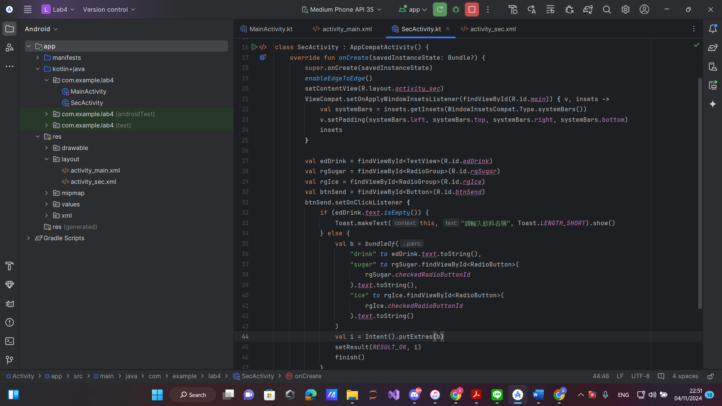

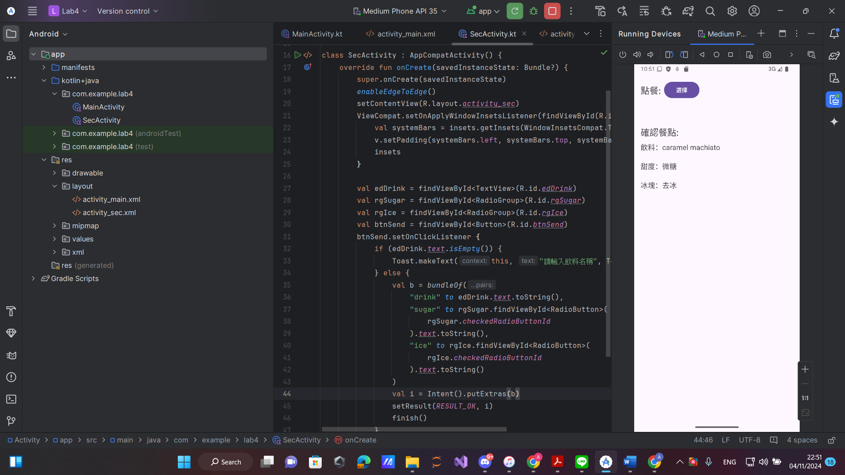

**Conclusion:** This Android application provides a user-friendly interface for selecting drink preferences through two interconnected activities. The MainActivity serves as the entry point, allowing users to initiate the selection process by launching SecActivity.

**1. User Interaction:**In SecActivity, users can enter their drink name and select sugar and ice levels using a text input field and radio buttons, allowing for intuitive customization of drink orders.

**2. Data Handling:**Upon submission, the app validates that a drink name is provided. If valid, it creates an Intent with the drink details and returns it to MainActivity using the activity result API, enabling easy retrieval and display of order details.

**3. Modern UI Design:**Both activities utilize edge-to-edge layouts, enhancing visual appeal and optimizing screen space on modern devices. Dynamic padding adjusts for system insets, ensuring a polished appearance across various screen sizes.

**4. Error Handling:**Basic error handling is implemented in SecActivity, with toast messages prompting users to enter a drink name if the field is empty, providing immediate feedback to improve user experience.

LAB 5 – Fragment :

Java :

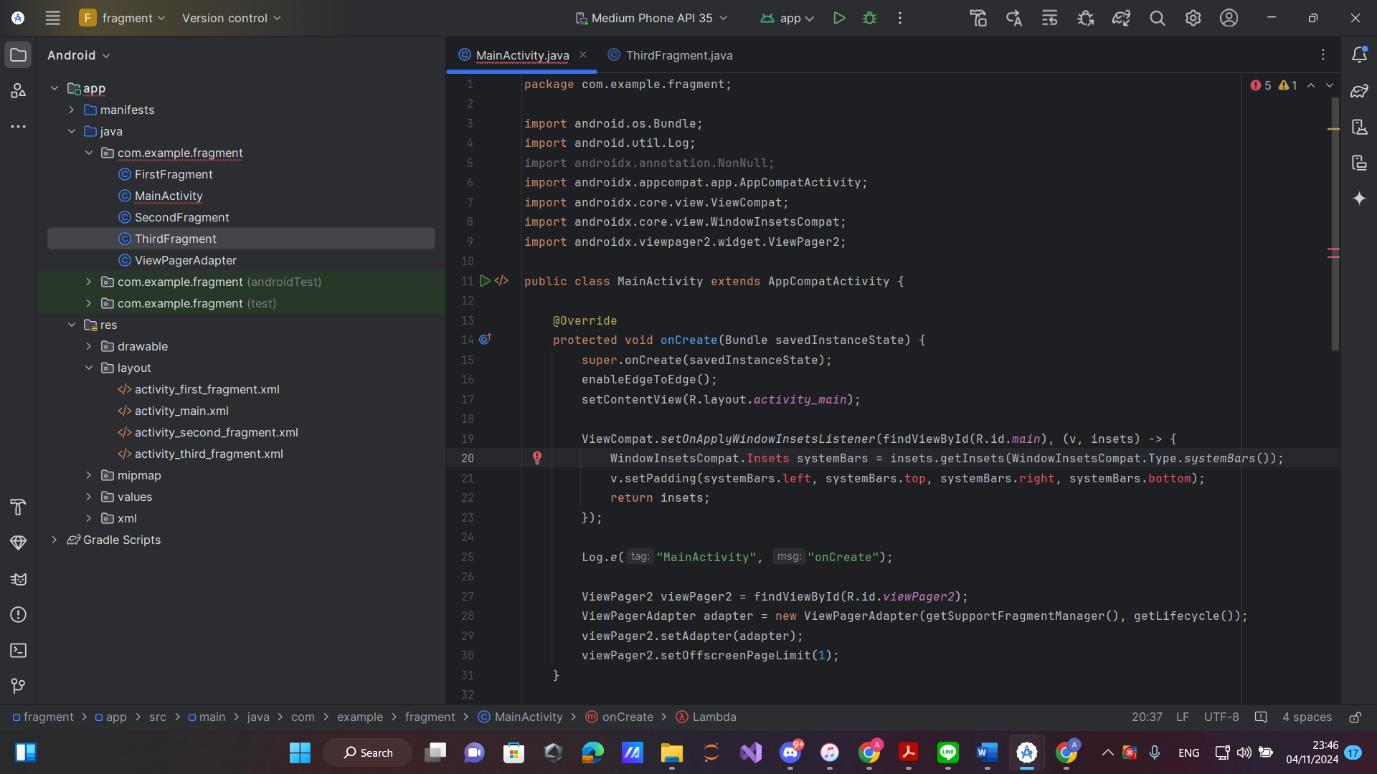

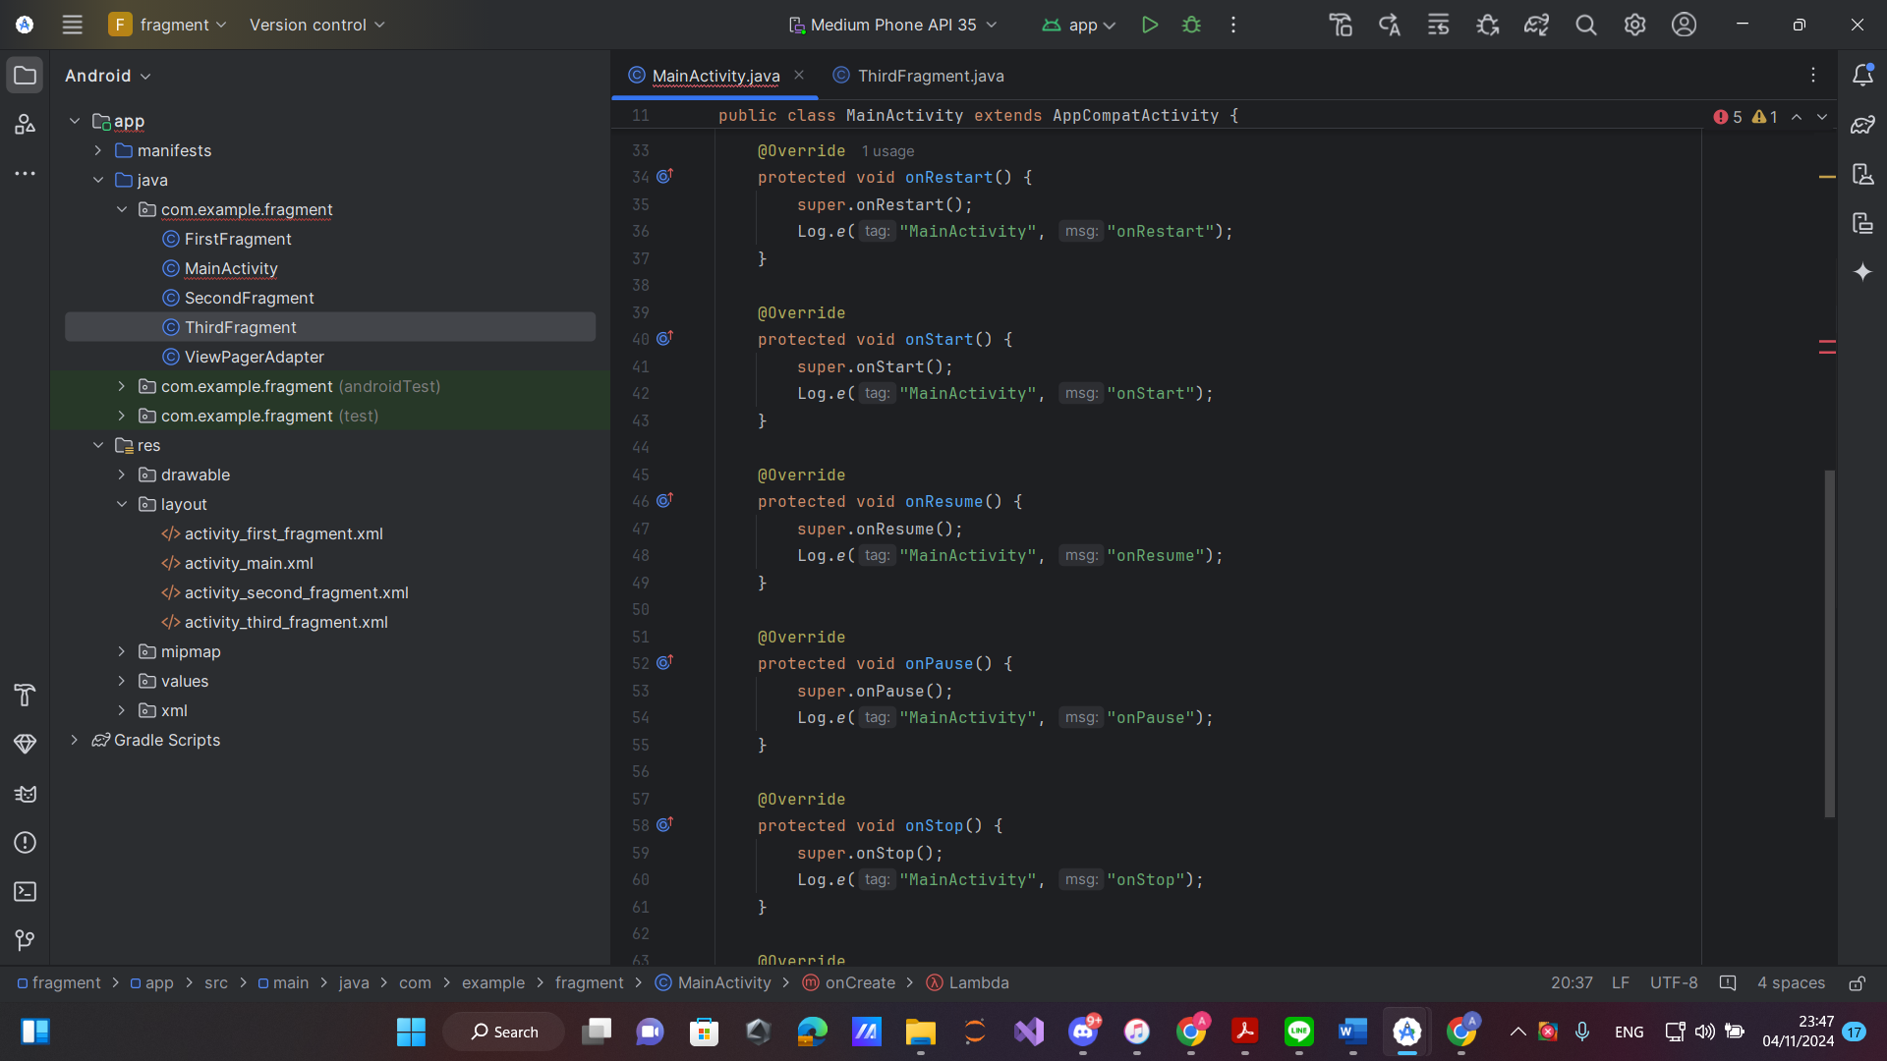

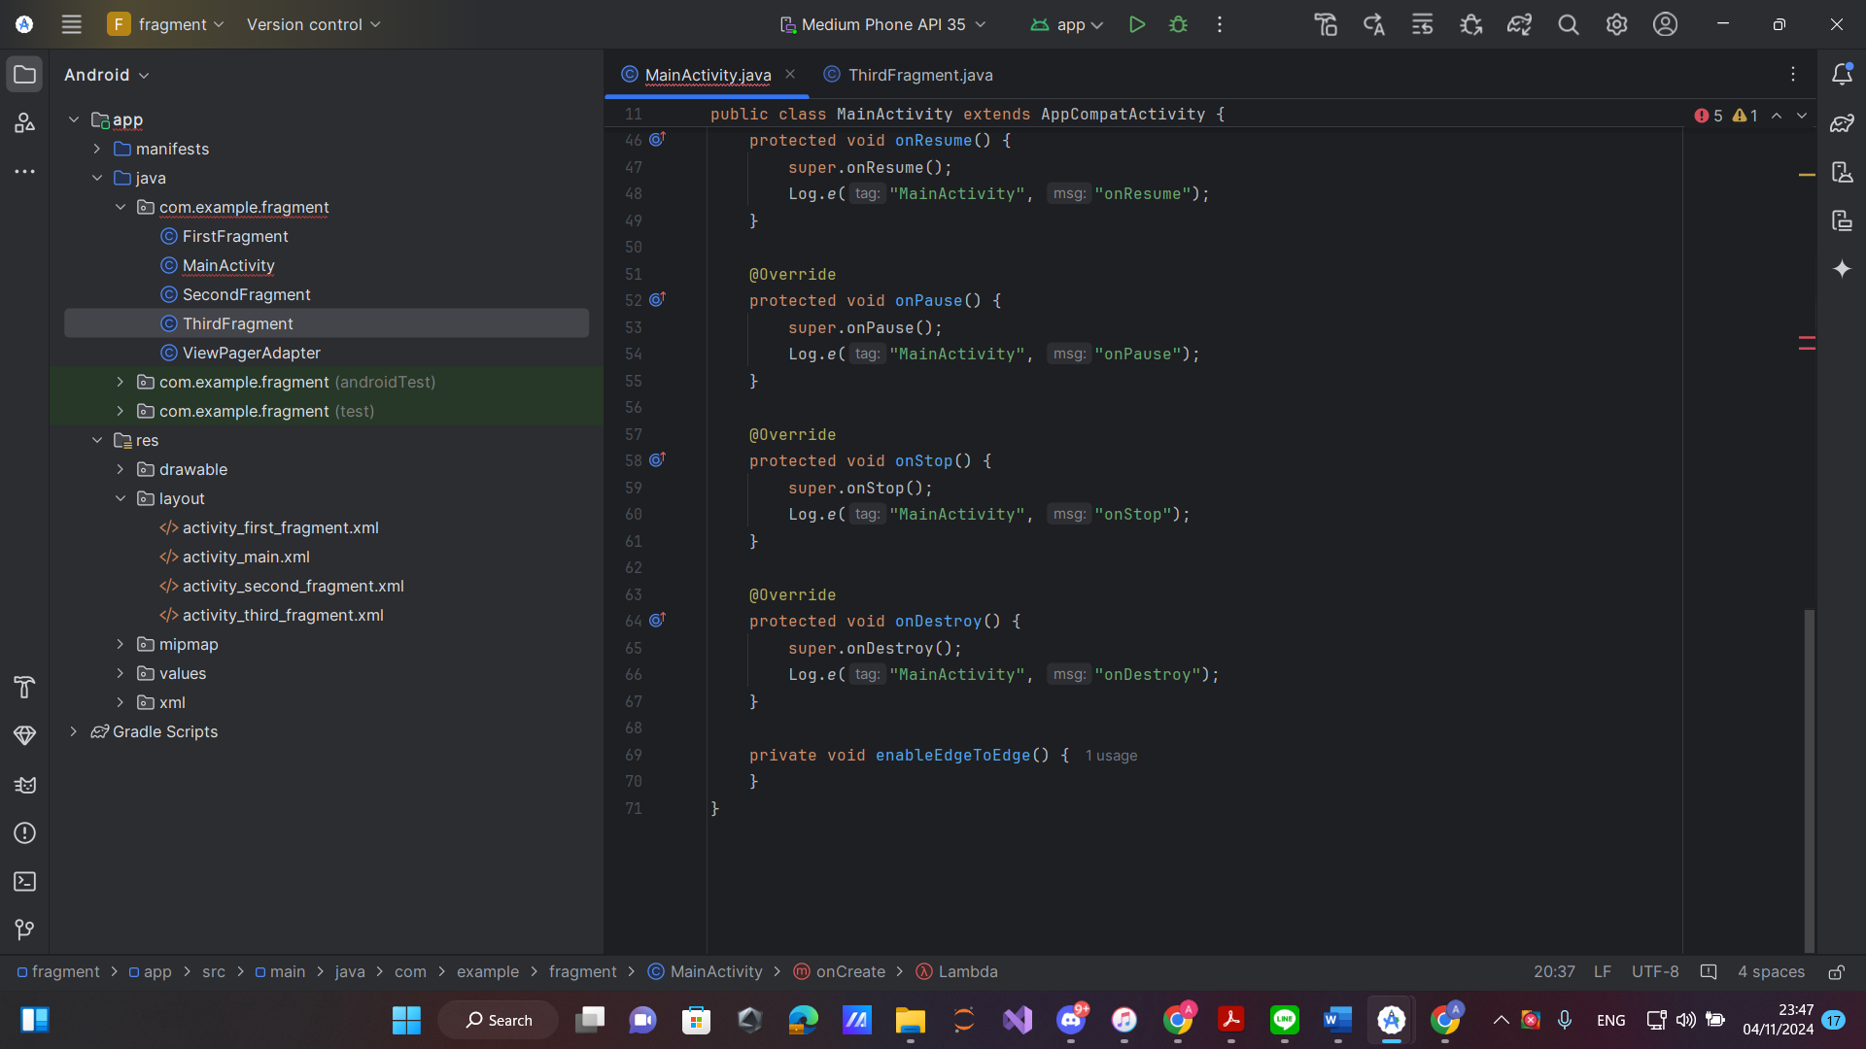

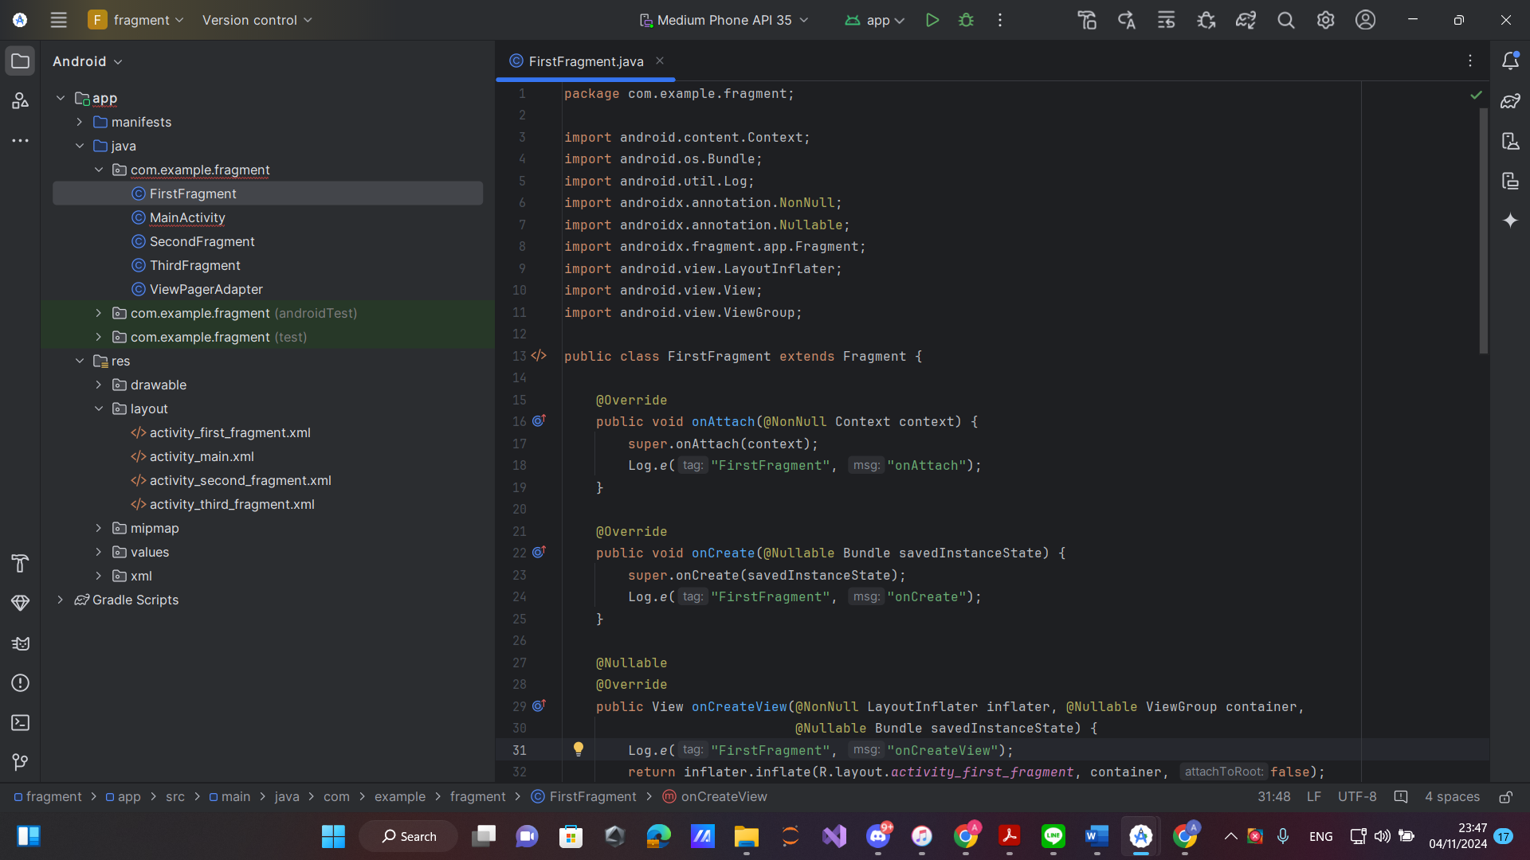

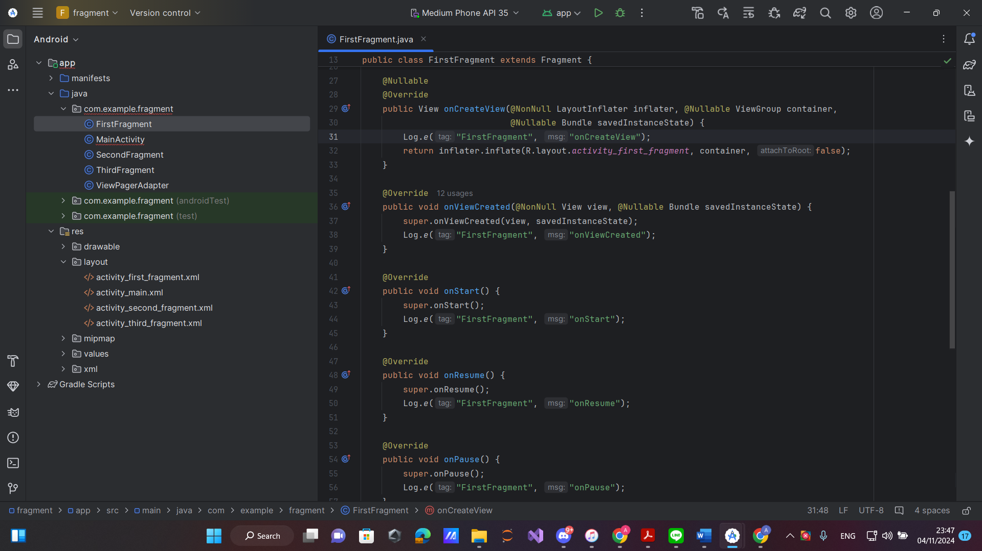

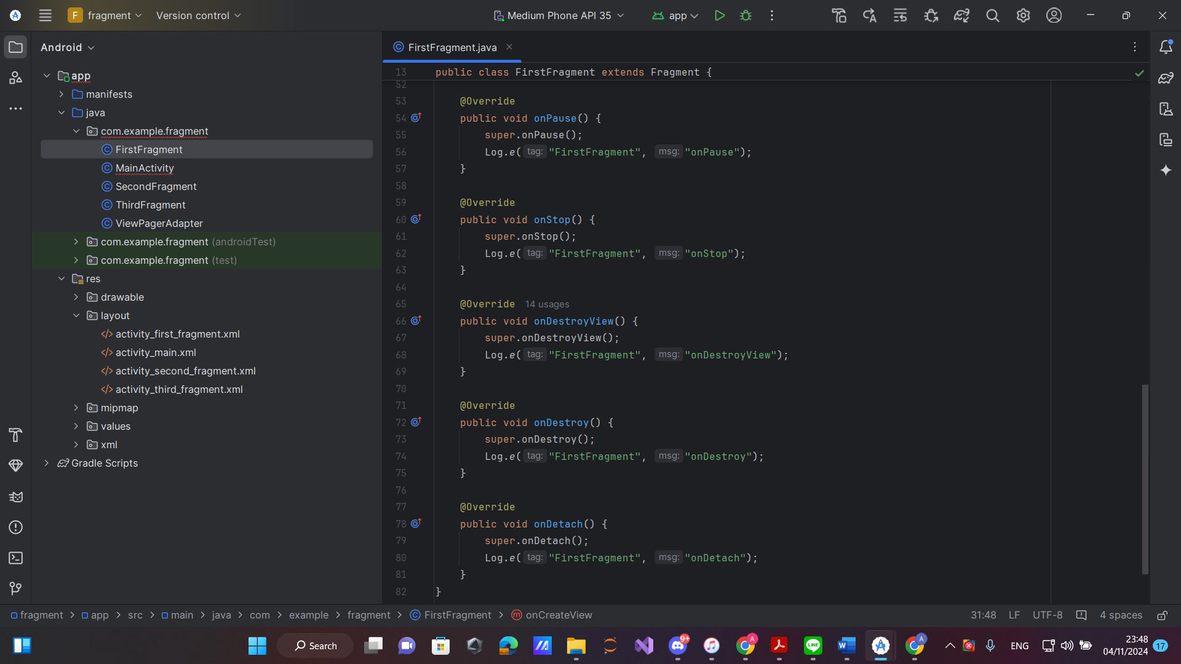

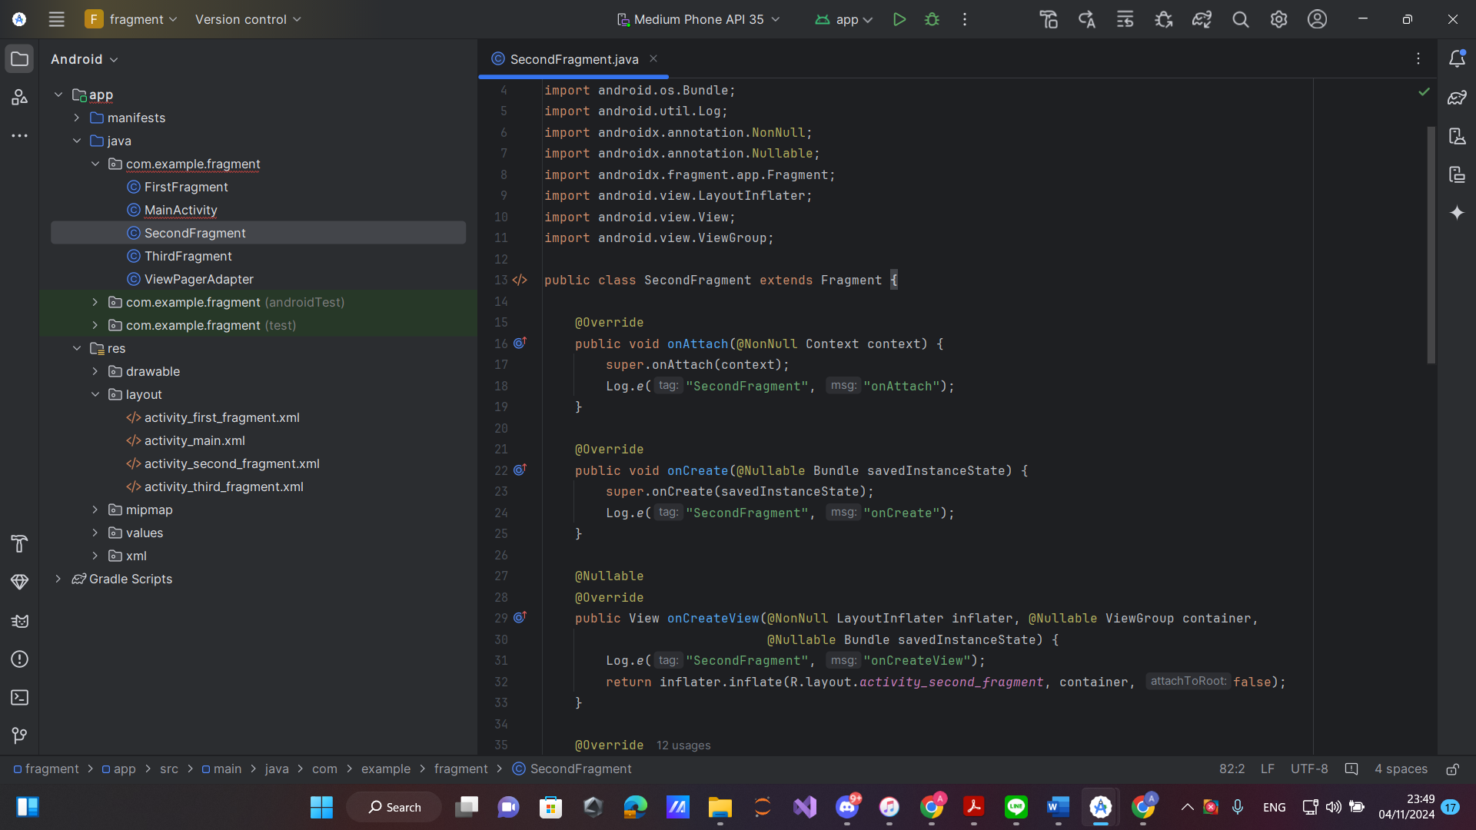

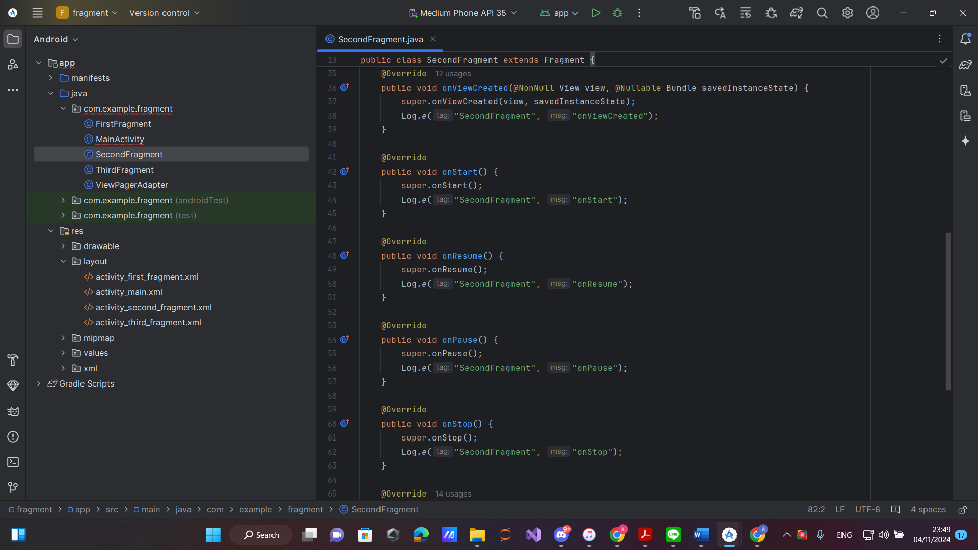

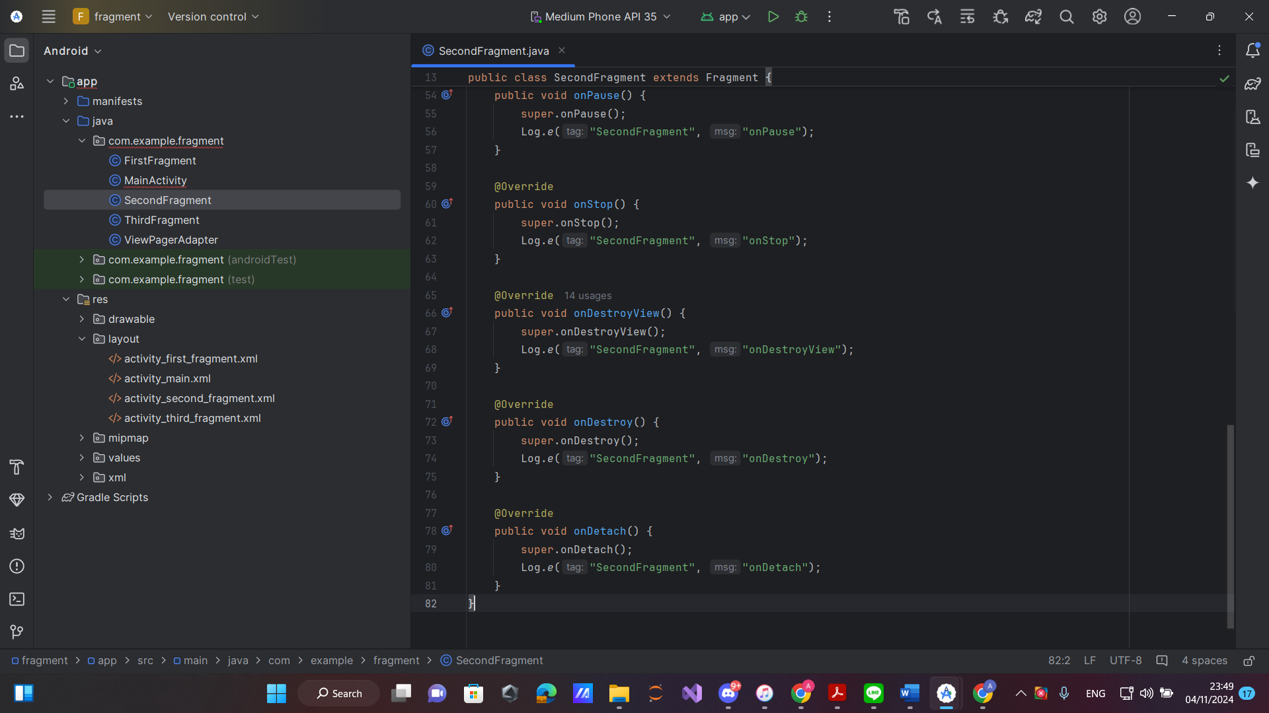

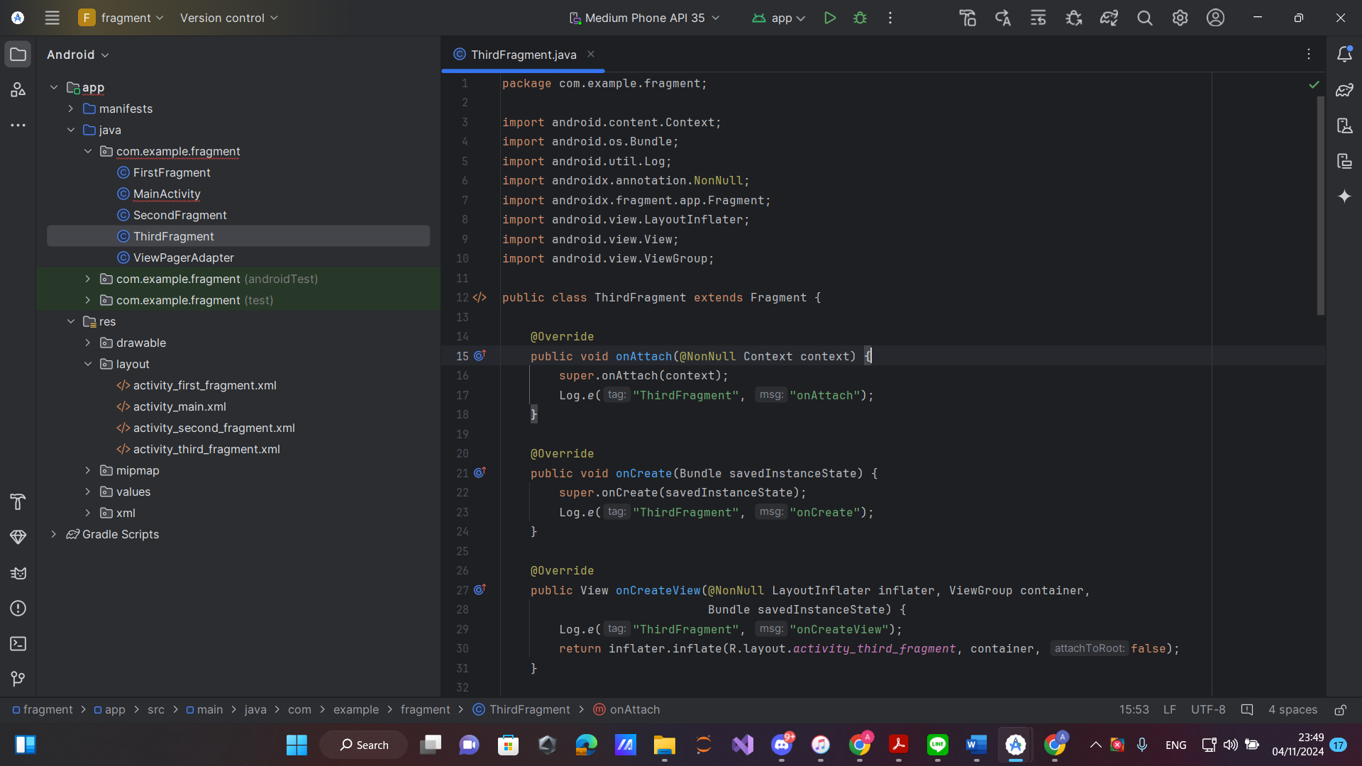

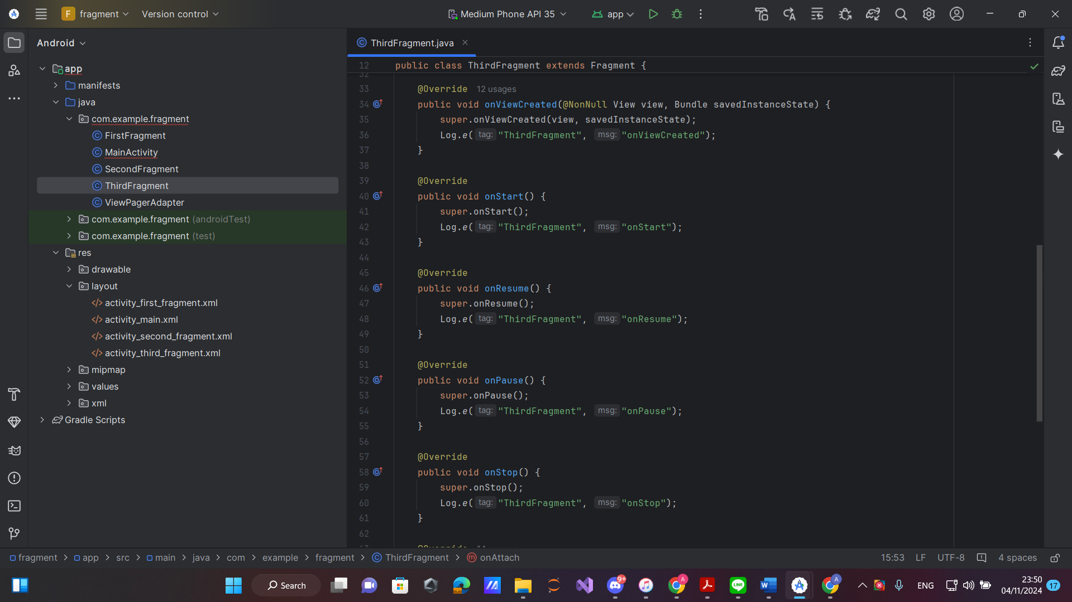

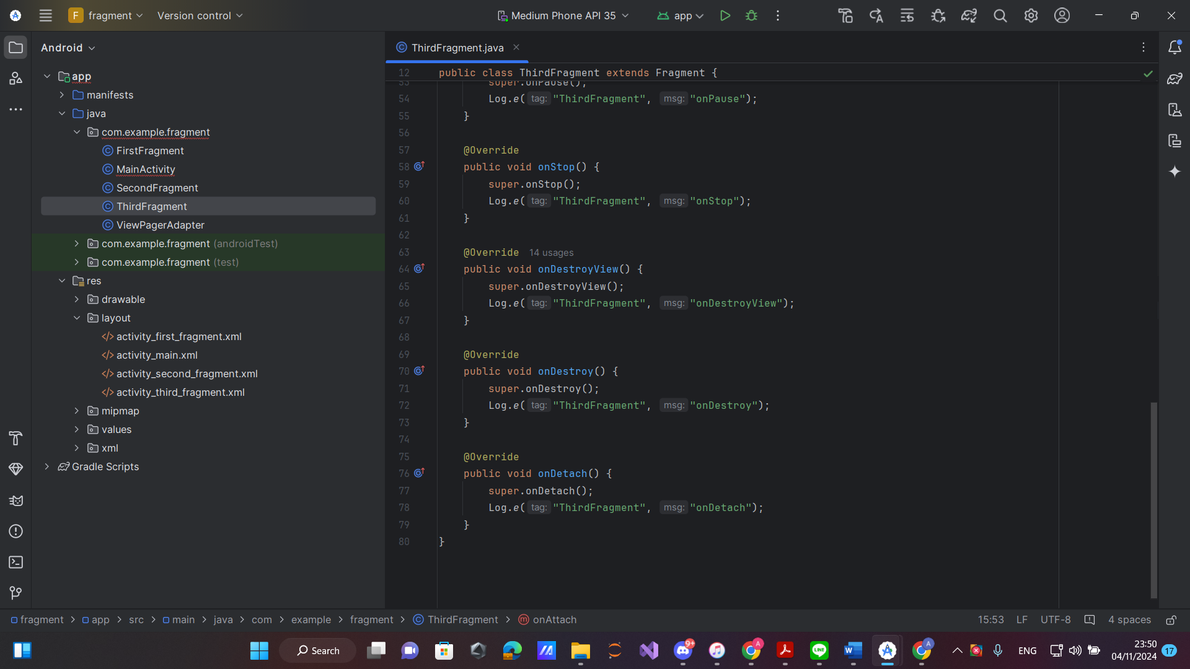

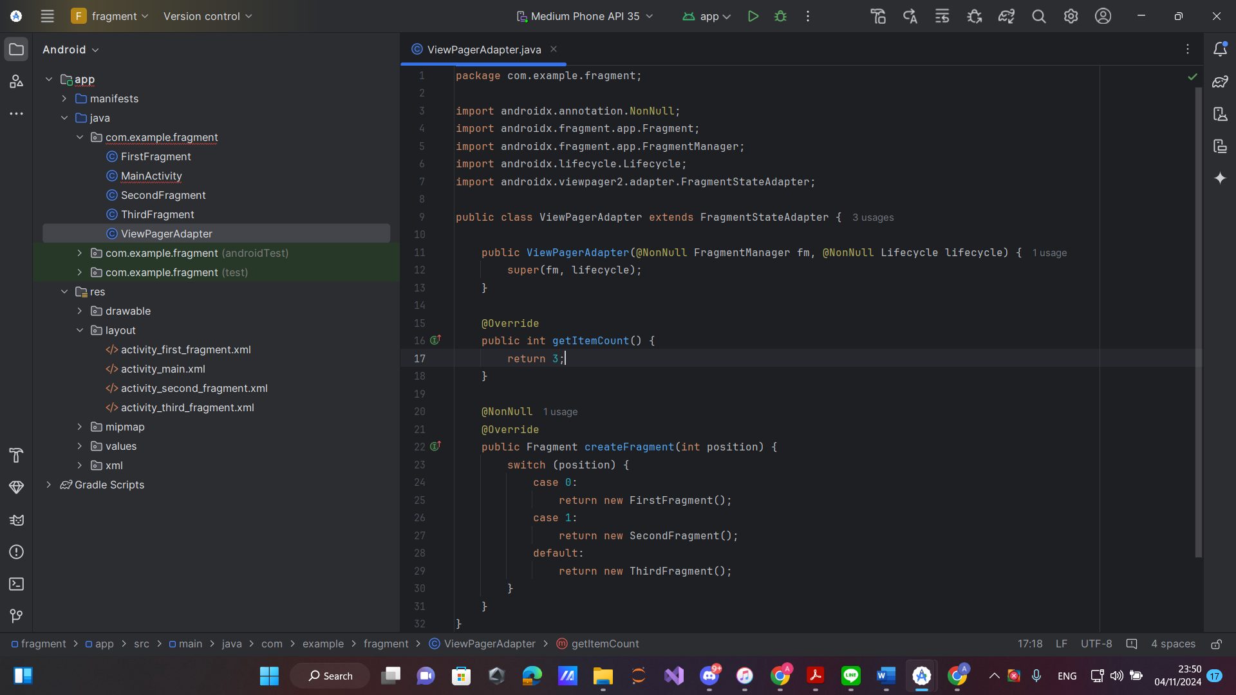

**Kotlin:**

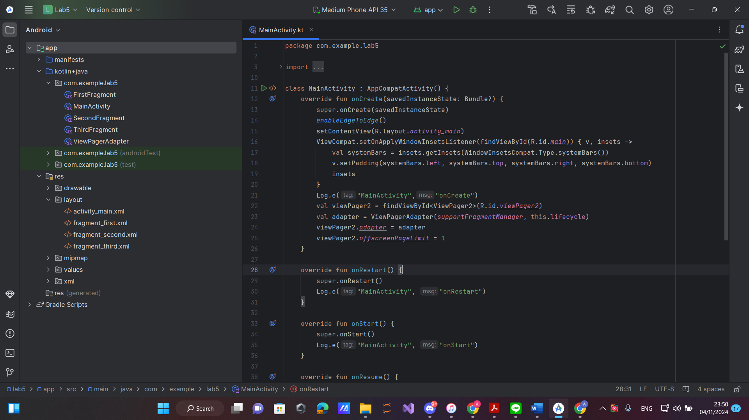

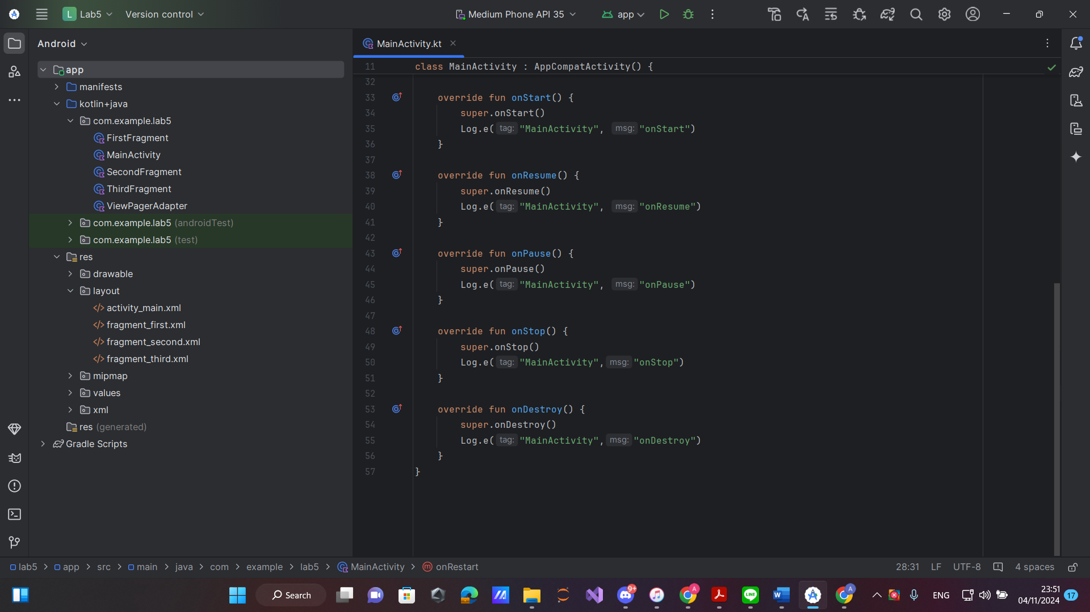

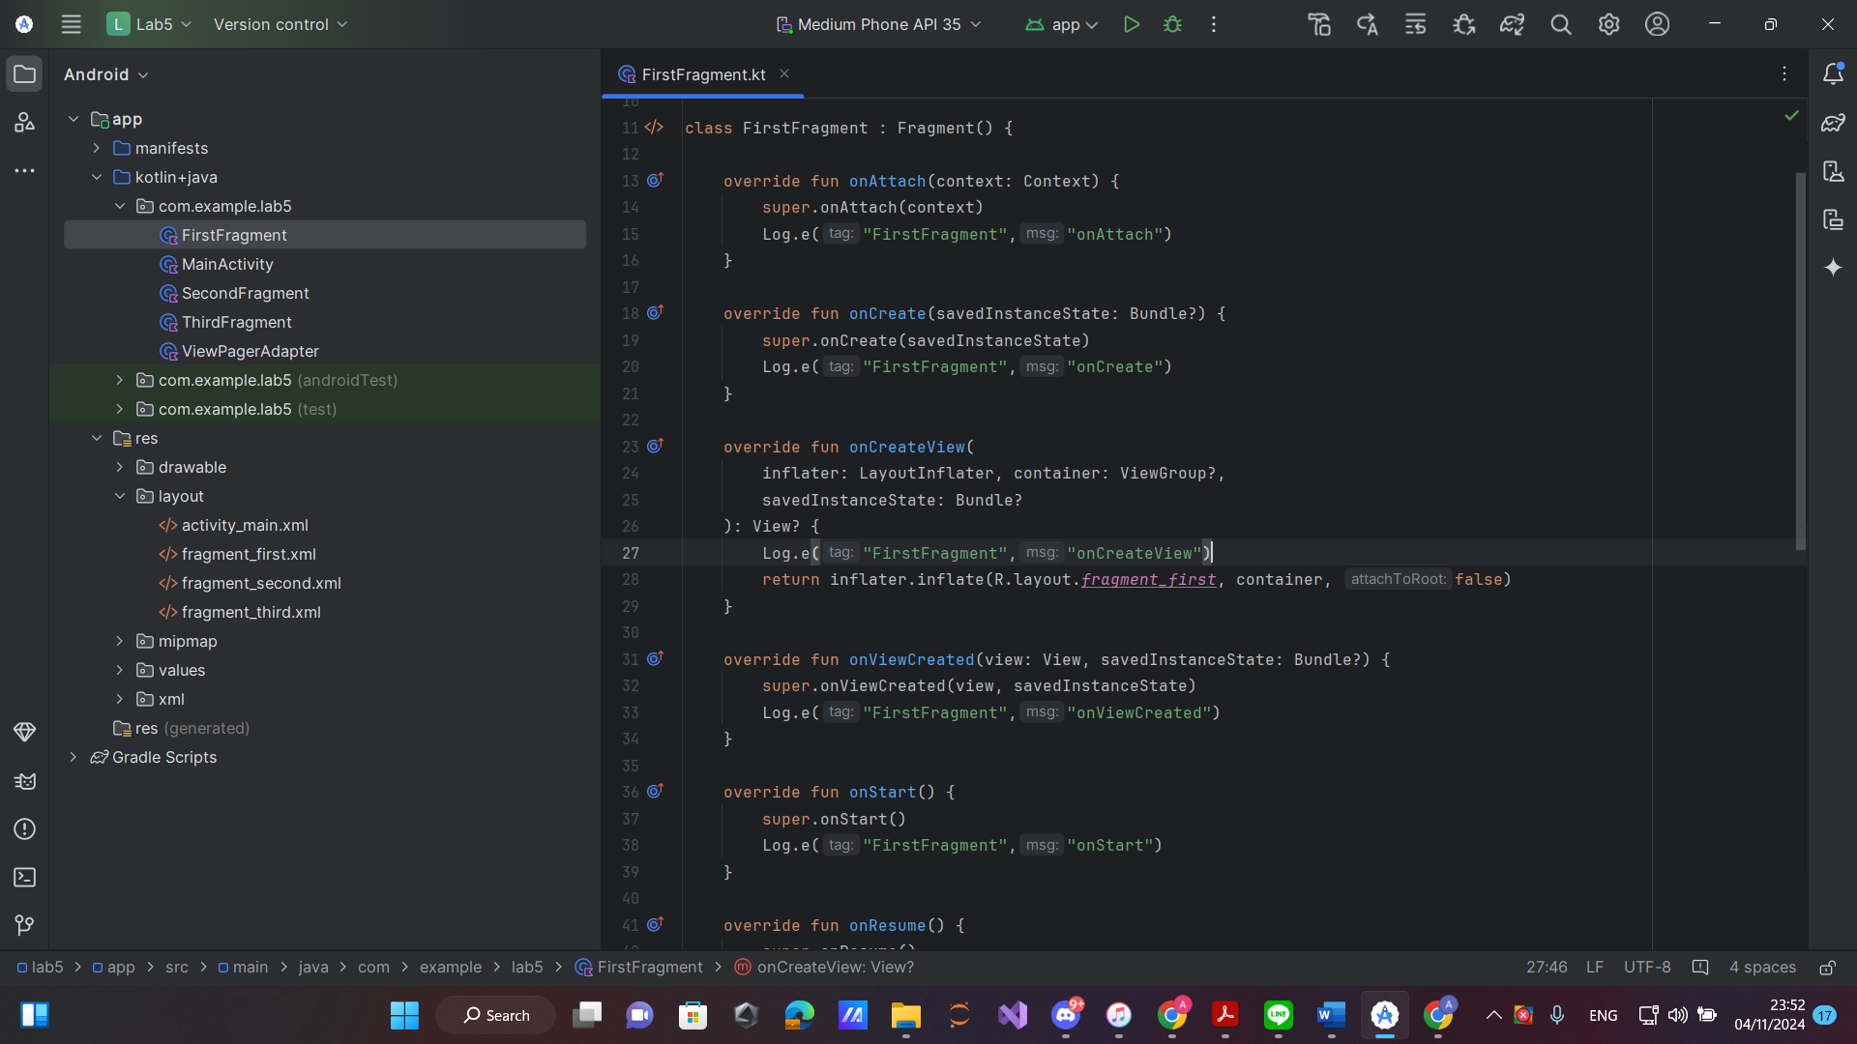

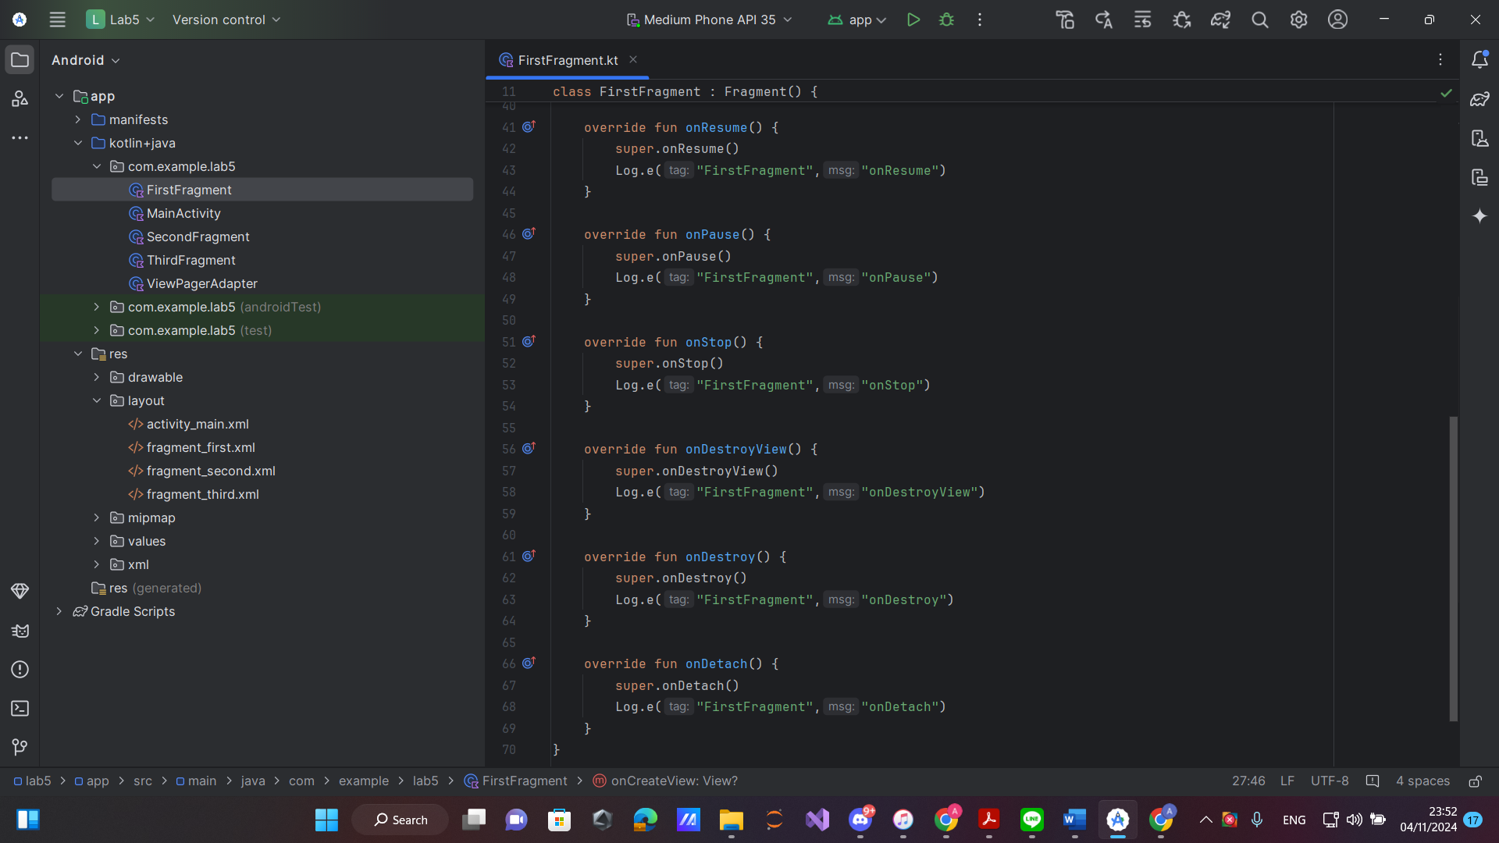

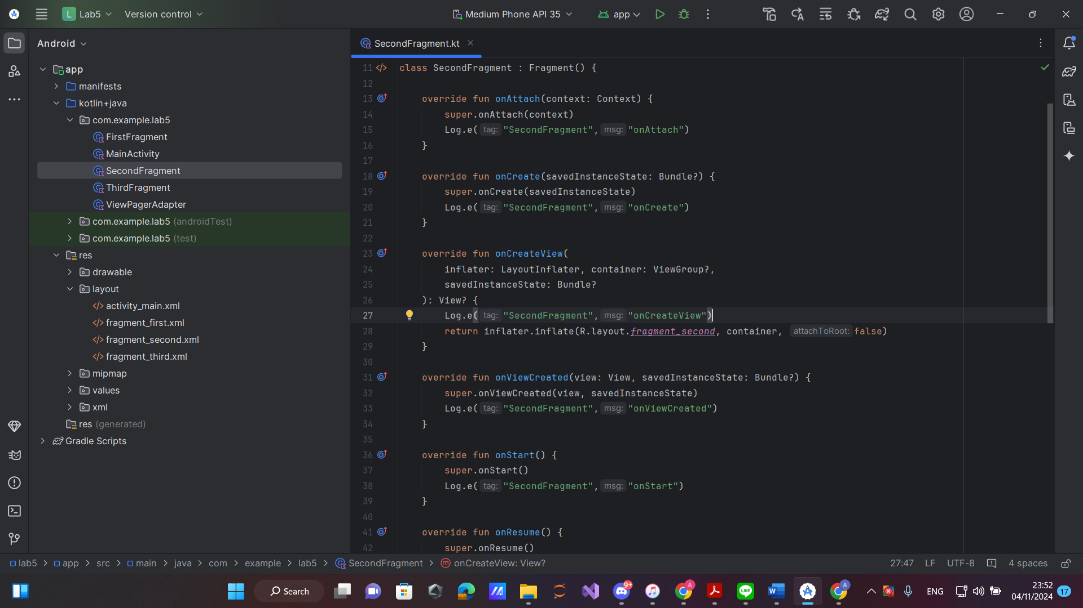

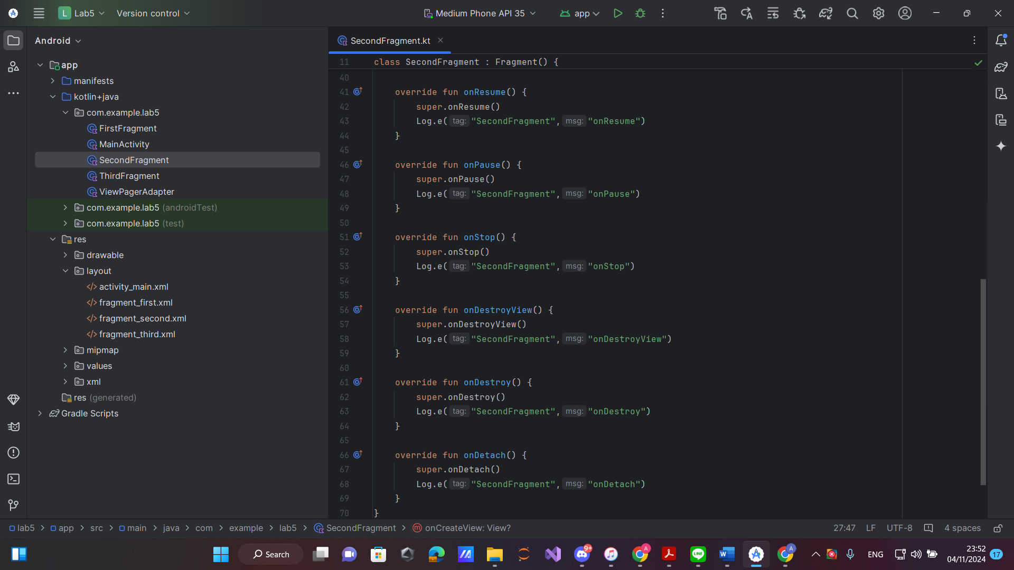

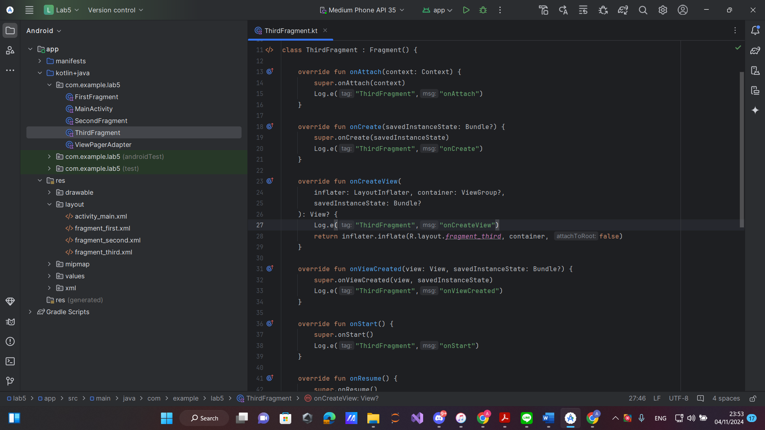

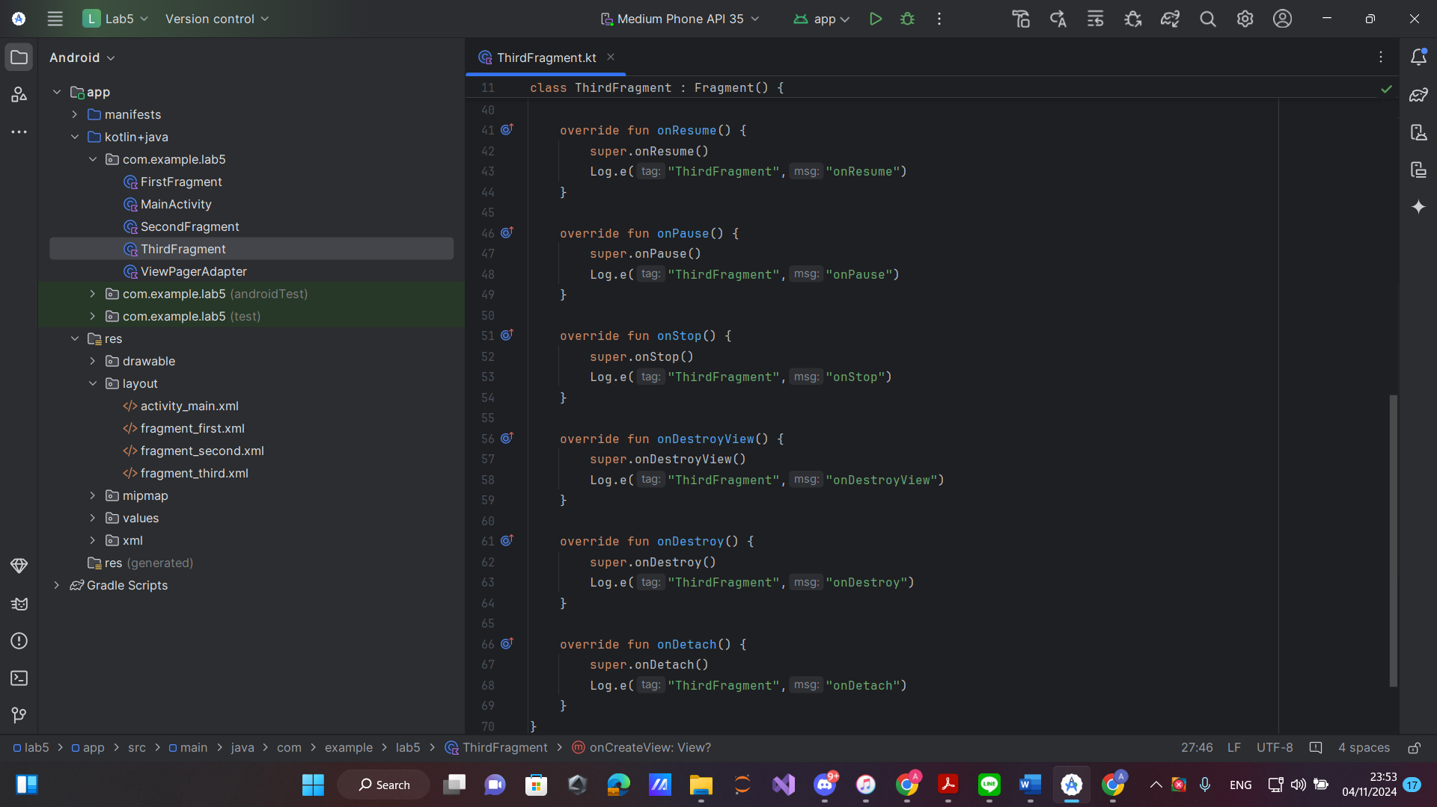

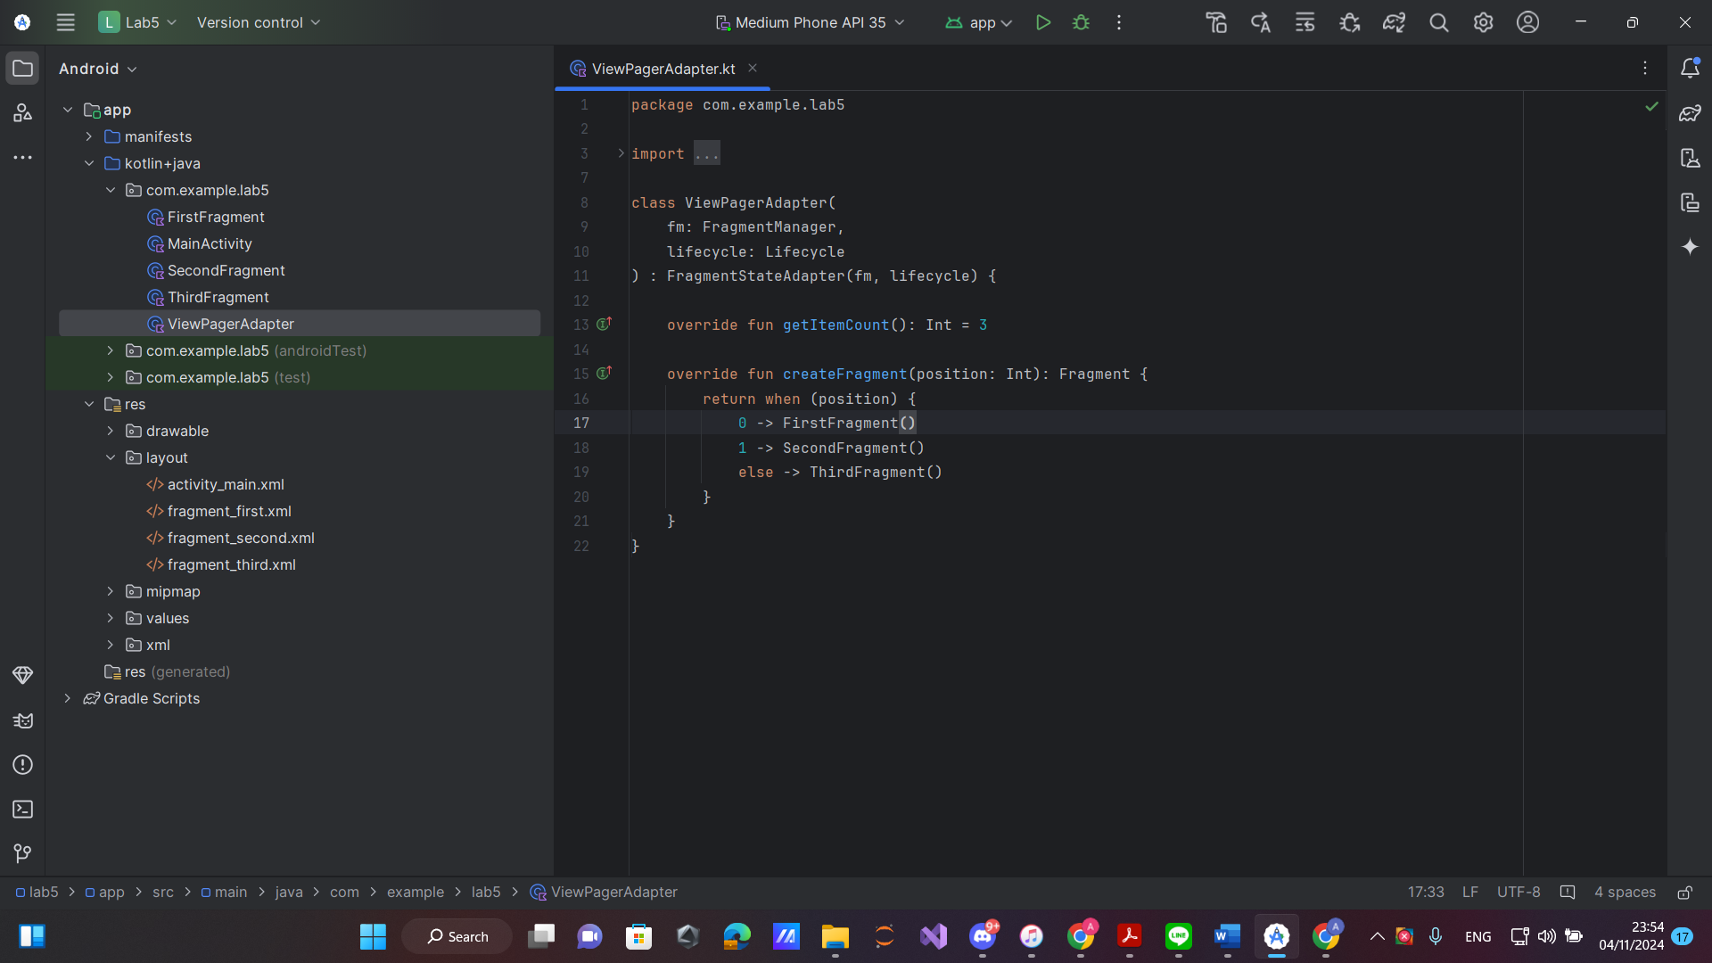

This Android app creates a swipeable interface using ViewPager2 with three fragments, managed by MainActivity and a ViewPagerAdapter. MainActivity enables edge-to-edge UI, setting padding based on system insets to ensure proper display across devices, while ViewPagerAdapter returns the correct fragment based on page position, with an offscreen page limit for optimal performance.

Each fragment (First, Second, and Third) logs lifecycle events, helping developers understand fragment states as users swipe through pages. This logging is valuable for debugging and tracking fragment behavior within ViewPager2, creating a flexible, efficient base for building multi-screen navigation in Android.

LAB6 - 訊息提示元件 :

Java:

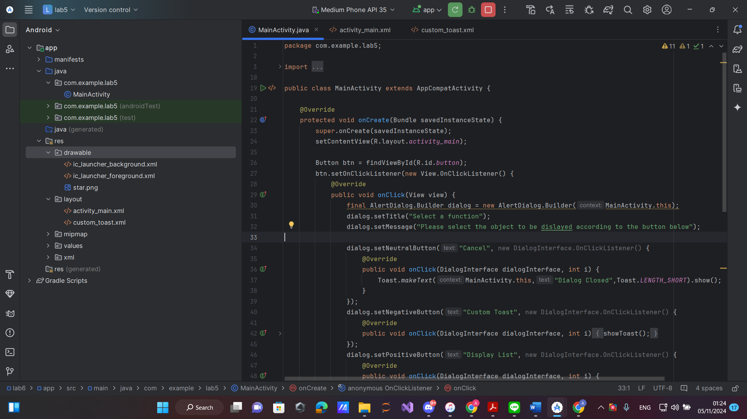

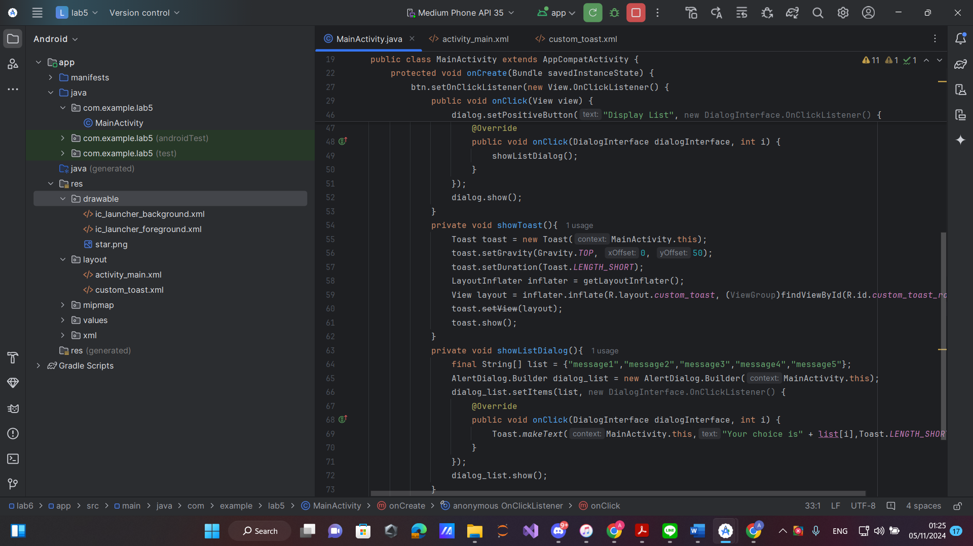

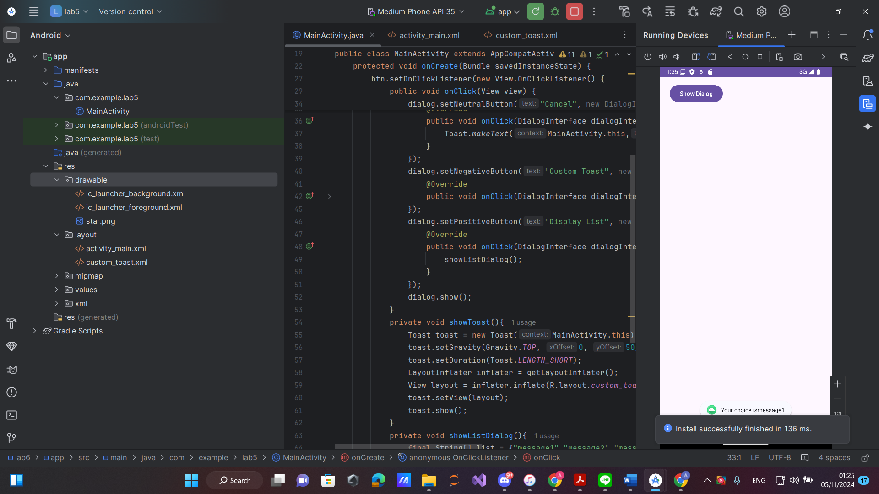

Kotlin:

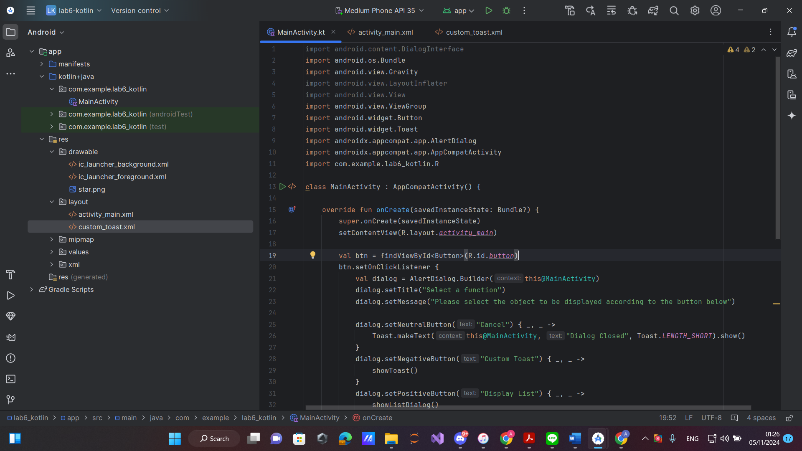

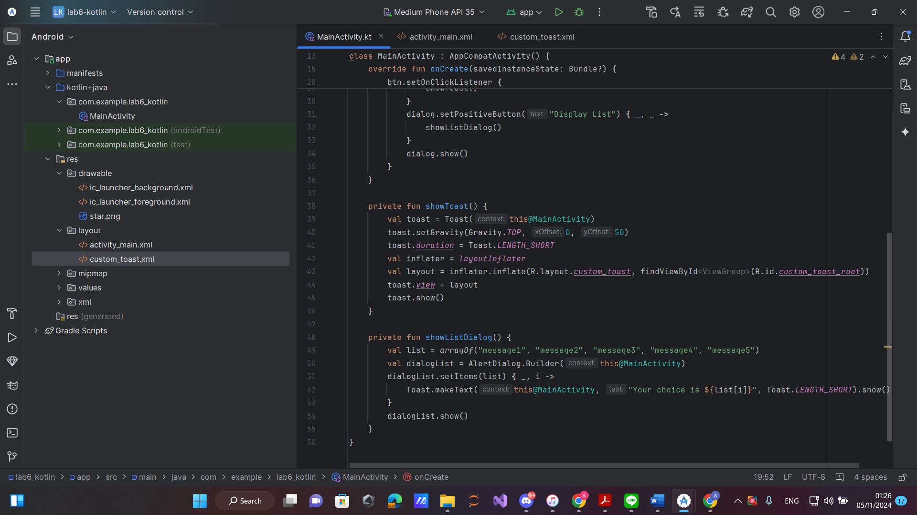

This Android program creates an interactive user interface using dialog boxes and custom toast messages. When a button is clicked, an AlertDialog appears with three options: "Cancel," which closes the dialog with a confirmation toast; "Custom Toast," which displays a custom toast message; and "Display List," which opens a selectable list with a toast showing the user’s choice.

The program demonstrates how to use AlertDialog and custom Toast components to provide quick, interactive feedback, enhancing user engagement. This setup is ideal for apps needing simple user choices and immediate responses, offering a clean, user-friendly experience.

**Question:**

1. In what situations should we use activities, fragments, and message prompt components?

In Android development, activities, fragments, and message prompt components serve distinct purposes, each suited to specific situations:

-. Activities: Activities are typically used to define individual screens within an application. They serve as the primary building blocks for an app's user interface, handling core user interactions and managing the lifecycle of the screen. Use activities when creating self-contained views that represent a complete and independent task or feature within the app.

-. Fragments: Fragments are modular UI components that reside within activities, allowing for flexible and reusable design. They are particularly useful in cases where you need to build dynamic or multi-pane layouts within a single activity, such as in tablet interfaces or apps with complex, nested interfaces. Fragments can share data and retain state across activity changes, making them ideal for managing parts of the UI that need to respond to different configurations.

-. Message Prompt Components (e.g., Toasts, Dialogs, Snackbars): Message prompts provide users with short, contextual information or feedback without disrupting their workflow. Toasts are useful for brief notifications, Snackbars are ideal for showing actionable messages, and dialogs prompt users for decisions or provide critical information. Use these components to communicate non-intrusive information, confirm actions, or guide the user’s next steps.

Each of these components plays a crucial role in creating an intuitive, user-friendly Android application, allowing developers to build structured, modular, and responsive interfaces.

1. Is it more difficult to use Java or Kotlin for implementing activities, fragments, and message prompt components?

Using Kotlin for activities, fragments, and message prompt components is generally easier and more efficient compared to Java. Kotlin offers several advantages:

1. Concise Syntax: Kotlin is more concise, which means less boilerplate code, making it quicker to write and easier to read. For example, Kotlin’s findViewById is streamlined with synthetic properties or ViewBinding, removing the need for explicit casting and reducing the likelihood of errors.
2. Null Safety: Kotlin has built-in null safety, which helps prevent common null pointer exceptions that can cause crashes. This feature is especially helpful when managing UI components that may or may not be present in certain configurations, such as fragments.
3. Coroutines for Asynchronous Tasks: Kotlin supports coroutines, making it simpler to handle asynchronous tasks, which are common when working with Android components like dialogs and data retrieval. This improves readability and reduces the complexity of callback handling.
4. Enhanced Support for Modern Android Development: Android's newer libraries and APIs are primarily designed with Kotlin in mind. As a result, Android Studio provides more optimized tools and features for Kotlin, making development smoother.

Overall, while both Java and Kotlin can be used to develop Android apps, Kotlin offers many features that simplify working with activities, fragments, and message components, leading to cleaner, more maintainable code.

1. What are the most commonly used functions when working with activities, fragments, and message prompt components?

When working with activities, fragments, and message prompt components in Android, several key functions are frequently used:

1. **For Activities**:
   * onCreate(Bundle savedInstanceState): Initializes the activity and sets up the UI. This is the main entry point for activity setup and where most initializations occur.
   * startActivity(Intent intent): Used to navigate from one activity to another.
2. **For Fragments**:
   * onCreateView(LayoutInflater inflater, ViewGroup container, Bundle savedInstanceState): Creates and returns the view hierarchy associated with the fragment, allowing the UI to be set up.
   * getActivity() or requireActivity(): Often used to access the parent activity from within a fragment.
3. **For Message Prompt Components**:
   * **Toasts**: Toast.makeText(Context context, CharSequence text, int duration).show(): Displays a brief message to the user, often used for quick feedback.
   * **Dialogs**: AlertDialog.Builder.setMessage(String message).setPositiveButton(String text, DialogInterface.OnClickListener listener): Used to create a customizable dialog, typically with actions.
   * **Snackbars**: Snackbar.make(View view, CharSequence text, int duration).show(): Shows an action-prompt message at the bottom of the screen, ideal for short, actionable messages.

These functions form the core of interaction within activities, fragments, and message components, helping manage lifecycle events, navigation, and user feedback.